Problem Statement
A university has a limited number of scholarships (here, 3). Many students apply. We must check each applicant against fixed criteria, rank only the eligible ones, and break ties fairly using predefined rules. Doing this by hand is slow and error-prone, so we automate it.
. Objectives
- Calculate each student’s aggregate (average) percentage.
- Check four eligibility rules: aggregate, subject-wise minimum, attendance, and income.
- Rank eligible students from best to worst.
- Resolve ties with a clear, ordered set of rules.
- Award scholarships to the top N and put the rest on a waitlist.
- Give a reason for every rejection, so the process is transparent.
Assumptions
Criterion | Rule
Aggregate | ≥ 60%
Each subject | ≥ 40 marks
Attendance | ≥ 75%
Annual family income | ≤ ₹3,00,000
Algorithm
- Define the rule constants (minimum aggregate, subject, attendance, maximum income, seats).
- Read the list of applicants.
- For each applicant:
  - Compute the aggregate = total marks ÷ number of subjects.
  - If aggregate < 60 → reject with the reason.
  - If any subject < 40 → reject with the reason.
  - If attendance < 75 → reject with the reason.
  - If income > 3,00,000 → reject with the reason.
  - Otherwise add to the eligible list.
- Sort the eligible list using the key (−aggregate, −Maths, income, −attendance, name).
- Assign ranks 1, 2, 3, …
- Ranks 1 to N → AWARDED; remaining → WAITLIST.
- Print the rank list and the rejected list with reasons.
Pseudocode
CONSTANTS: MIN_AGG=60, MIN_SUBJ=40, MIN_ATT=75, MAX_INCOME=300000, SEATS=3

FUNCTION aggregate(marks):
RETURN sum(marks) / count(marks)

FUNCTION check_eligibility(student):
IF aggregate(student.marks) < MIN_AGG RETURN (False, "low aggregate")
FOR each mark in student.marks:
IF mark < MIN_SUBJ RETURN (False, "low subject mark")
IF student.attendance < MIN_ATT RETURN (False, "low attendance")
IF student.income > MAX_INCOME RETURN (False, "high income")
RETURN (True, "")

FUNCTION ranking_key(student):
RETURN (-aggregate, -maths_marks, income, -attendance, name)

MAIN:
eligible = [], rejected = []
FOR each student in applicants:
(ok, reason) = check_eligibility(student)
IF ok: add student to eligible
ELSE: add (student, reason) to rejected
SORT eligible BY ranking_key
FOR rank = 1 to length(eligible):
IF rank <= SEATS: status = "AWARDED"
ELSE: status = "WAITLIST"
PRINT rank, student, status
PRINT rejected list
Test Cases
# | Student | Input highlights | Expected result | Rule tested
1 | Esha | Marks 95, 95, 35; aggregate 75 | Rejected: English 35 < 40 | Subject-wise minimum
2 | Farid | Attendance 70% | Rejected: attendance | Attendance rule
3 | Gita | Income ₹5,00,000, top marks | Rejected: income | Income rule
4 | Hari | Aggregate 55% | Rejected: aggregate | Aggregate rule
5 | Asha, Bharat, Charan, Divya | All aggregate 85 | Ordered by tie-breakers | Tie resolution
6 | Charan vs Divya | Same aggregate; Maths 95 vs 90 | Charan ranks above Divya | Tie-break rule 2 (Maths)
7 | Divya vs Asha | Same aggregate and Maths; income ₹1L vs ₹1.5L | Divya above Asha | Tie-break rule 3 (income)
8 | Asha, Bharat, Charan, Divya, Indu | 5 eligible, 3 seats | Top 3 awarded, rest waitlisted | Seat limit
Output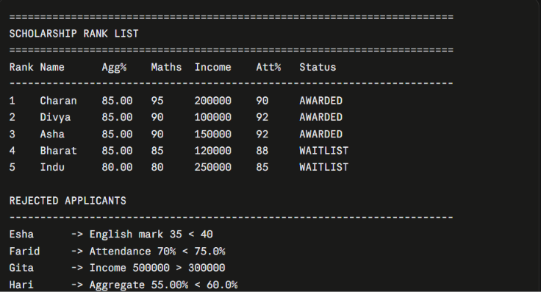
Flowchart
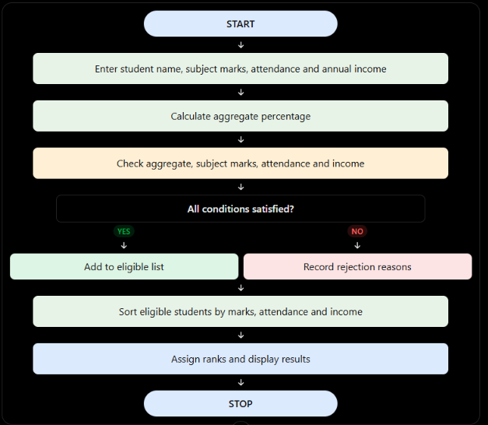
Conclusion
The system filters applicants with four eligibility rules, ranks the eligible ones, and uses a fixed, ordered set of tie-break rules to decide between equal candidates. Every rejection comes with a reason, which keeps the process transparent and fair. All rules are stored as constants at the top of the program, so the university can change the policy without touching the logic.

